EXPOSING THE TRINITY DOCTRINE

Why am I exposing the trinity doctrine as a false doctrine? -- Because it is a false doctrine, and it needs to be exposed! But, it is not just any run-of-the-mill false doctrine--it is a foundational doctrine that has kept people from knowing and understanding the real Elohim (God) of the Hebrew Scriptures, and knowing the real Hebrew Messiah of Israel. All false doctrines have their root in Satan/Lucifer, who seeks to draw worship from Yahuweh and Yahushua unto himself. All such doctrines appeal to the intellectual mind by use of deception. Use of a little Scripture makes them look true. The gullible, the ignorant, the naïve, and the lazy, are targets for deception because they either do not have a Bible to read in their own language, or they are too lazy to read what they have. In the Western world it is overwhelmingly the latter. Those who love pure undefiled Truth, and have access to the Scriptures, must wisely seek truth from its Source--the mind of Yahuweh. Tragically, Christian missionaries have unloaded tons of false doctrines on those in third world nations, making the people dependent on their teachings, or the teachings of visiting ministries. But, for those who have access to a Bible of their own, if one is truly born of the Spirit by faith in Messiah, and the Spirit is invited into the temple of their re-born spirit, the Spirit of Yahuweh who gave us the Scriptures in the first place through His servants, is our Teacher. (II Peter 1:20-21; II Timothy 3:15-17)
He directs to sources that He approves of, some secular, too. But, He has to be in control of our education! To willfully choose to substitute a man’s teaching for His teaching – well – a person deserves to be deceived. Yahuweh ultimately will send strong delusion to those that don’t love His Truth so that they will believe the lies of false teachers even to their own damnation. (II Thessalonians 2:8-12) If we love truth, we’ll wisely go to the Source of Truth for our knowledge and understanding. Judgment on willful rejection of the Spirit’s teaching is found throughout the Scriptures.
So, who is this “Spirit?” -- A force, an “it,” or a “holy ghost”? NO! He is Yahuweh Himself extended into the earth, into the temple within the midst of those truly born again by the Spirit. Just as the tribes were positioned in an orderly manner around the tabernacle in the wilderness by Moses, so our body is positioned around the temple of our spirit in the midst of us – in the areas of digestion and reproduction.
At the true new birth, He perfects our spirit and prepares it for His entrance. Once asked, Messiah immerses us into the Spirit of His Father, and He fills us and encircles us. Once He has entered, He comes to teach, guide, direct, convict of sin, transform us into His nature, with His thinking, and help us to walk in His ways. Having the nature of Messiah is the sign of a true new birth. (II Corinthians 5:17) “Old things have passed away – behold – all things have become new.” [Refer to: “The True New Birth”]
Now, let us proceed to look at the root of this spurious doctrine of the Trinity, so that we might know the real Father and the real Son/Messiah of the Scriptures – the Elohim of Abraham, Yitzak, and Ya’cob, “whom to know is life eternal.” [Refer also to: “Sixty-Six Teachings and Assumptions Found in Christian Evangelical/Charismatic Churches That Have No Scriptural Foundation”/October 10, 2012]
From my article, “Exposing the Lies of Monotheism”/June 26, 2010, page 3: “The doctrine of the trinity denies that there is a separate Father and a Son. The Catholic Encyclopedia defines “trinity” this way: “The Father, Son, and Holy Spirit are three hypo-stases, or personalities, of one being.”
I didn’t realize our one Creator had multiple personalities, did you? No wonder everyone has His opinion of what to believe. No wonder the confusion in the 38,000 Christian denominations and organization, when we have a God with one body and three heads like one of the Hindu gods, or one body and three different persons living in the one body – sounds psychotic. Today, a person who has one body and different personalities would be taken to a mental hospital. No one can know what He is, or who He is if he switches from one personality to another, or from one mood to another. How can we know and trust someone like that, with changeable rules for right-standing with Him, with varying promises--wow!
But, according to almost all Christian denominations, “God, the Father,” is very unstable. He gives His people a Covenant by which they identify with Him as their Elohim (God), then He sends His Son to throw it all in the garbage, and for everyone to start over with a totally new set of rules, overseen by a totally different personality – the Apostle Paul. I promise you, the Apostle Sha’ul is not guilty! [Refer to: “Putting Torah in Its Proper Place”]
Each denomination has a slightly different view of His personality, how He thinks, and what He does. That is confusion! Who knows what to believe or how to act to please Him? Supposedly with one being and three manifestations of the one being, they all act and think alike. Yes, the Father and the Son act and think alike, but they are two distinctive Beings, as we see throughout the Scriptures. While the Father is in heaven, from Genesis to Revelation we find the Son manifesting on earth--first in a spiritual body (thought tangible), and secondly in a physical body on earth.
If Christianity is right, then there is something wrong with Abba (Father) Yahuweh, Elohim of Israel! He says His Covenant with His people is forever. The Christian God trashes His Covenant (Torah) that He made with His people, including the signs of identification with Him for His people-–His biological people, the 12 tribes of Ya’cob --for a “new” one that is for gentiles. He changes who His people are, too. Formerly they were the twelve tribes of Ya’cob (Jacob), but after Messiah, they are gentiles. In the “Old Testament” He is vengeful and full of wrath, and demands obedience. But, in the New Testament he is a teddy bear, soft and cushy, who overlooks the violation of His Torah (the teachings and instructions for right-standing in the Kingdom of heaven), and lets everyone think and do as they please, as long as they go to church and pay their tithe.
Some groups say He is “Jesus only.” There is an ancient Gnostic Christian doctrine that says God filled a body--a “sark”--and it was God the Father who took flesh. Then there is the heresy of “Monotheism.” There are all types of human reasoning, theology, doctrines, theories, and other absurdities. But, each has its following by naïve, gullible, ignorant, or lazy people. Religion keeps people ignorant for the purpose of controlling them.
Why doesn’t someone ask Him who He is? Wow – what a novel idea.
Is He so mixed up that He can’t talk to His people? Or is it that His people are so mixed up that they can’t hear from Him? I strongly believe the latter! All theology is, is a substitute for knowing the real Person (singular) of Yahuweh--the Father, the Almighty, the Most High – the only true, living, Elohim of Israel, and His Son (singular), Yahushua Messiah.
Man analyzes, reasons, and argues about Someone they do not know, by-passing clear teaching from Genesis to Revelation, rejecting teaching from His Spirit, to listen to the messy opinions of men. Why? Because man in general fears submitting his will and his life to anyone higher than he is--man wants to be God! So, man invents ideas about God, and wraps religion around his concepts, but all it does it to keep man from knowing Him.
The concept of one Being with three personalities manifested in three ways, is basic to the heresy of Gnosticism. The first brand of Christianity, created by the Greeks and Hellenized Jews in the first century was a conglomerate of paganism from several nations, and was originally Gnostic. They taught that Messiah was a mere man. The purpose of creating the counterfeit was to block and hopefully eliminate the teachings of the Apostles about the Elohim of Israel and His Hebrew Son. The Torah was disgusting to both Greeks and Romans, so the foundation of Christianity became the rejection of His wonderful and life-giving Torah, dubbing it the “law of the Jews.” Believe me, the Apostle Yochanan (John) would never have referred to the Torah as the “law of the Jews,” nor called the Festivals, “the Festivals of the Jews.” The Torah is not just for the House of Judah, but for the whole House of Ya’cob – all the tribes. If you simply look at Revelation 12:17; 14: speaking of those in the last days, you will see that the true believers guard the Covenant/Torah of Yahuweh and have the witness that they are saved by Yahushua Messiah. Where’s the “Holy Ghost?”
“Holy, Holy, Holy, Lord God Almighty; God in three Persons, blessed trinity,” is a famous song written by Bishop Heber of the Roman Catholic Church during the Counter Reformation, in defense of the Trinity doctrine. Evidently the Church became defensive of the Trinity doctrine because some Protestant Reformers questioned it! Oh, I used to sing that song loudly. I loved the bold melody. Maybe a Messianic could come up with better words, like “Set-Apart, set-apart, set-apart is Elohim Shaddai; Elohim in two Persons--blessed Deity Duo.” There would surely have to be a new melody!
But where did the Roman Catholics get this doctrine? Remember, Christianity from its inception appealed to the pagans of the Greek world. Greek gods, and later Roman gods, were saviors who had sons (sun gods) who were saviors. Constantine, creator of the Roman Catholic Church and first pope, worshipped Sol Invictus Mithra (sun god of Persia) to his death.
The unifying foundation of the entire church system, from Nimrod onwards, has been to exalt a “trinity.” But, as we’ll see later, a Trinity is a common link throughout all major pagan religions. By doing this they sought to ruin Yahuweh’s reputation, separate He and His Son, stop the use of Their correct Hebrew Names, pervert Their Word to appease pagans, usurp Their rightful authority to rule Their Creation, by replacing Them with the worship of false gods and humans who were the god’s representatives (i.e. popes, cardinals, bishops, priests). You can get the whole story in my mini-book The Foundation of Deception, available on Amazon Kindle for 99 cents, or from my website directly – comeenterthemikvah.com
For your enjoyment (smile) here are some Catholic paintings of their Trinity.

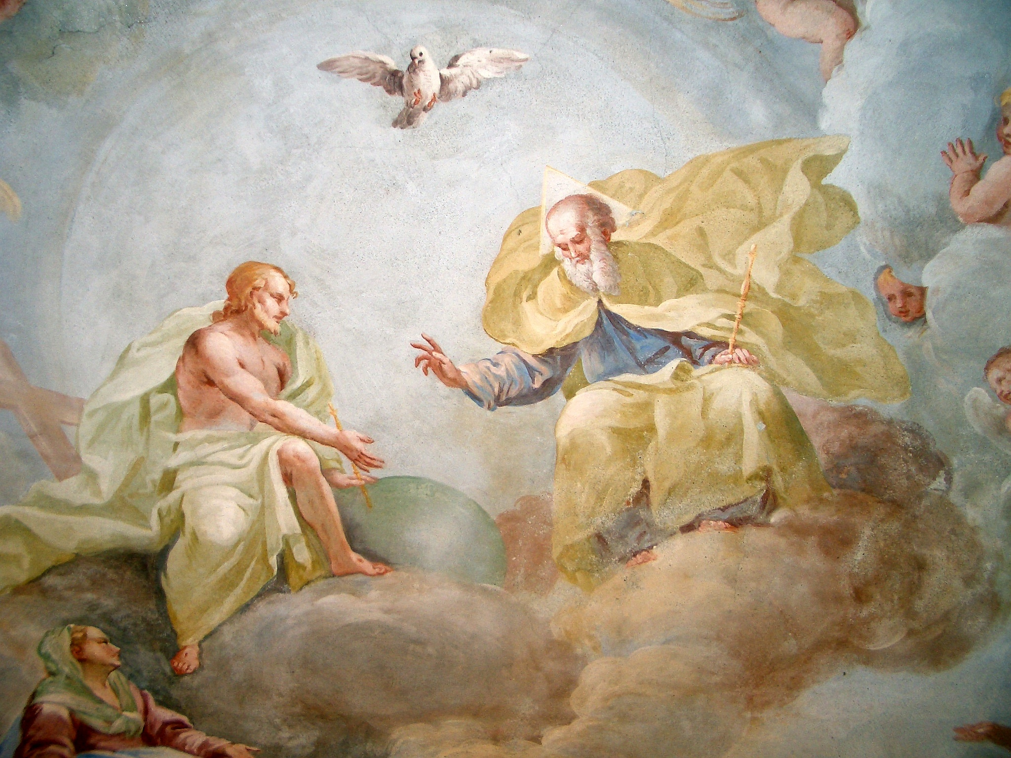
Holy Trinity, fresco by Luca Rossetti da Orta, 1738-9 (St. Gaudenzio Church at Ivrea, Torino)

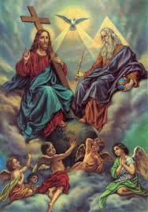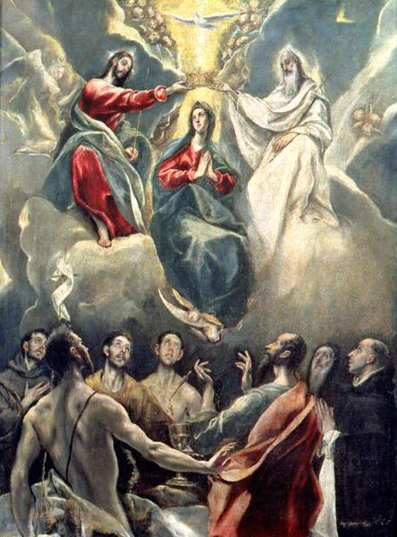
Left above: Notice that Jesus is showing two fingers – representing the spiritual and temporal powers of the pope… This two-finger gesture is common in Catholic paintings of Jesus
Right above: The Coronation of the Virgin by El Greco (1541-1619)
Notice that above Mary, Queen of heaven, mother of God, is overshadowed by the dove – an ancient symbol from paganism for a “holy spirit.”
Why is the Spirit pictured as a dove? Is that something original with the Roman Catholic Church, or does it have its origin thousands of years previously?
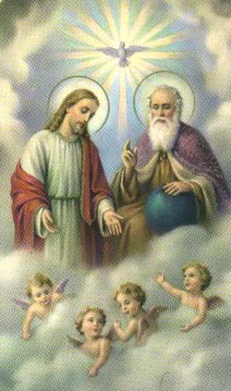
Here notice that God the Father is making the two-finger gesture of the pope’s earthly (political) and spiritual powers over all mankind. Notice that this “spirit” is in a pagan sun disc.

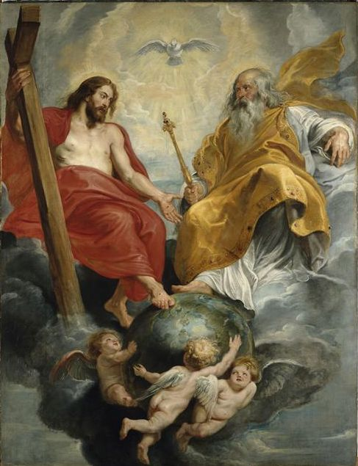
Peter Paul Rubens 1577 - 1640
The Trinity

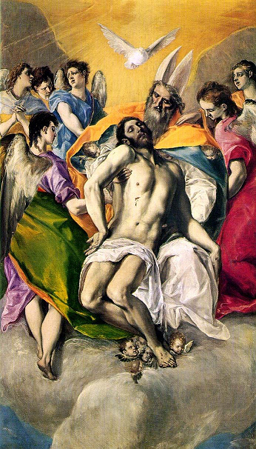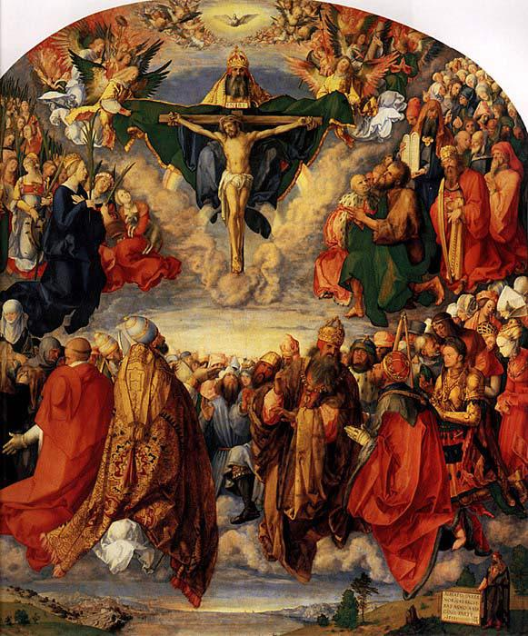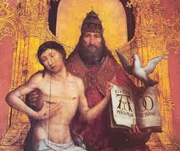
Left: The Holy Trinity by El Greco—Spain--Notice the pope’s Dagon fish hat on “God the Father”… Middle: The Adoration of the Holy Trinity
by Albrecht Dürer (1471 – 1528) …Notice the pope’s three-tier crown of the pope on “God the Father,” and also in the third picture on the right.

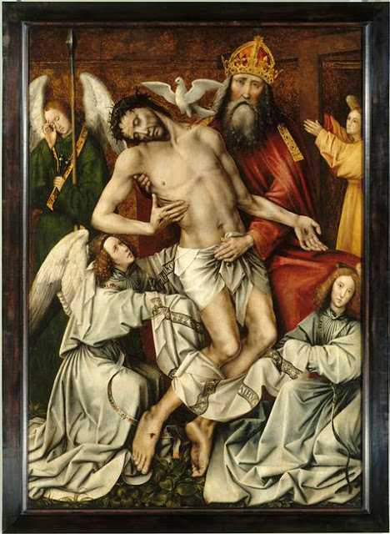
Colijn de Coter 1455 - c 1538
There’s that three-tier pope’s crown again on God, and that dove hovering over the dead Christ.

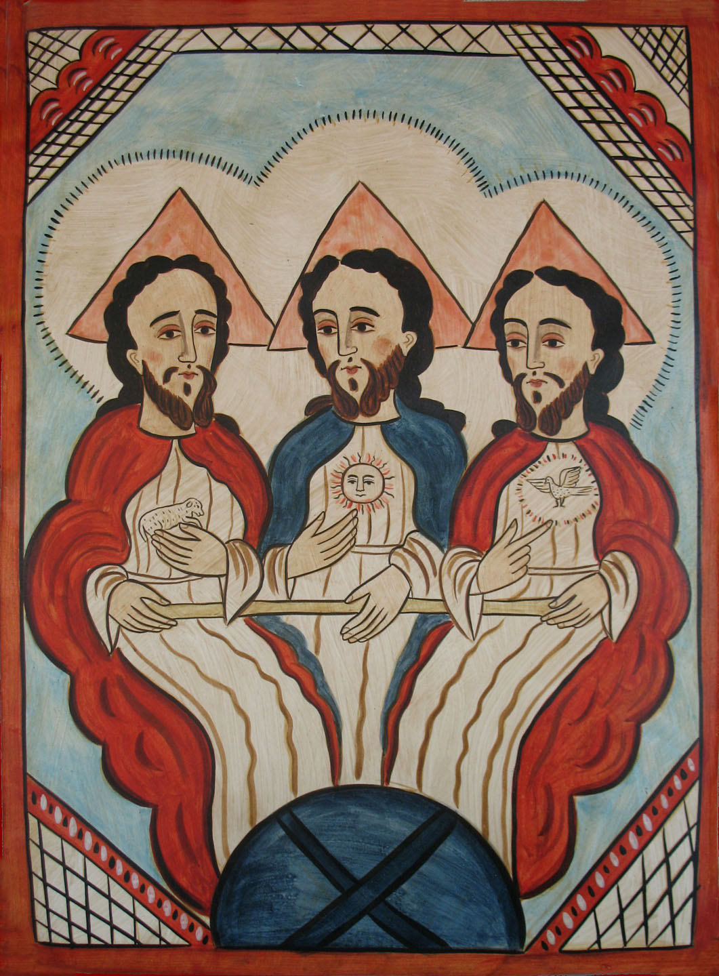
Retablo of the Holy Trinity, painted by New Mexican santero Alcario Otero in 2001
Notice the sun symbol on the Father, the dove on the Spirit, and Jesus holding the Lamb... Nimrod, Semaramis, and Tammuz…
Notice their heads are framed by pyramids?

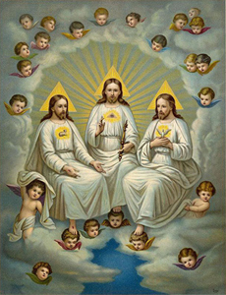
The three look-alikes again …Notice the sun-god images in this picture…

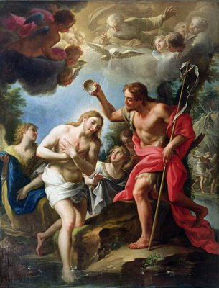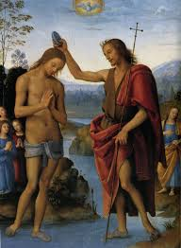
Paintings of Jesus’ baptism … The words of Matthew 3 are used to “prove” a trinity – which it does not. [From the Catholic Defender, Feast of the Holy Trinity] The sprinkling with water is far from the mikvah that Yahushua did in the River Jordan. I don’t think Yahushua was nearly naked in front of all those people either. Notice that all the features of the people in the paintings are European? Notice that most of the time Jesus looks in his 40s.

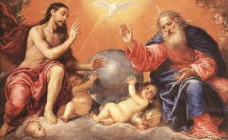
The two fingers again! Which one of those fat babies is Atlas?
Why is Jesus always running around with a loin cloth that can easily fall off?
It is noteworthy that the sun gods, like Zeus, were also pictured nearly nude, wearing a draped loin cloth.

From the Catholic Bible 101:
In 382 AD, Pope Damasus I, at the Council of Rome (the Council where the Canon of the Bible was first established), declared the following:
"If anyone denies that the Father is eternal, that the Son is eternal, and that the Holy Spirit is eternal: he is a heretic. If anyone says that the Son made flesh was not in heaven with the Father while He was on earth: he is a heretic. If anyone denies that the Holy Spirit has all power and knows all things, and is everywhere, just as the Father and the Son: he is a heretic."
During the Eleventh Synod of Toledo in Spain (675 AD), the Holy Catholic Church declared the following:
"We confess and we believe that the holy and indescribable Trinity, Father, Son, and Holy Spirit is one only God in His nature, a single substance, a single nature, a single majesty and power. We acknowledge Trinity in the distinction of persons; we profess Unity because of the nature or substance. The three are one, as a nature, that is, not as person. Nevertheless, these three persons are not to be considered separable, since we believe that no one of them existed or at any time effected anything before the other, after the other, or without the other.
St. Patrick explained the doctrine of the Holy Trinity to his flock in Ireland by using the three leaves of the shamrock. Each leaf represented one of the three persons, but yet it was still only one shamrock. If we take a look at our self, each human is made up of a mind, a body, and a soul, and yet we are still only one person. A fire has flames, heat, and light, but yet it is still just one fire. When you hear a person's speech, you are hearing three things - his words, his thoughts, and his voice. When you strum one chord on a guitar, it is made up of 3 separate notes, all equal to each other. Everything in nature is in 3 dimensions - length, width, and height (coincidence?). And while these examples help to explain the concept of three in one, the Holy Trinity is so much more.
For instance, where Jesus is present, the Father and Holy Spirit are also present, because they are one. Where the Father is present, Jesus and the Holy Spirit are also present simultaneously. Where the Holy Spirit is present, the Father and Jesus are also present in one person (This constant three-in-one presence is called "circumincession.") This means that when we receive the Eucharist at Mass, which is truly the body, blood, soul, and divinity of Jesus Christ, we are also receiving the Father and the Holy Spirit, because they are one.”
From Wikipedia on the Trinity:
The Christian doctrine of the Trinity (from Latin trinitas `triad’, from trinus `threefold’) defines God as three consubstantial persons, expressions, or hypostases: the Father, the Son (Jesus), and the Holy Spirit; `one God in three persons.’ The three persons are distinct, yet are one "substance, essence or nature. In this context, a `nature’ is what one is, while a `person’ is who one is.
According to this central mystery of most Christian faiths, there is only one God in three persons: while distinct from one another in their relations of origin (as the Fourth Lateran Council declared, `it is the Father who generates, the Son who is begotten, and the Holy Spirit who proceeds’ and in their relations with one another, they are stated to be one in all else, co-equal, co-eternal and consubstantial, and `each is God, whole, and entire.’ Accordingly, the whole work of creation and grace is seen as a single operation common to all three divine persons, in which each shows forth what is proper to him in the Trinity, so that all things are `from the Father,’ `through the Son’ and `in the Holy Spirit.’[
[My note for clarification on the above: Man has a physical body, and a spiritual body that lives inside the physical body. They look identical and each has its own substance. The spiritual body contains a soul (mind, emotions, will) that works through the brain, is connected to the five senses and this earthly carnal life. The soul is also our earthly life-force that moves through the blood, the DNA. The spiritual body has a separate spirit, which, if born again, becomes an open portal to the dimension of Yahuweh and Yahushua. Thus we are not a trinity – we are in the image and likeness of our Father and His Son--two. (Genesis 1:26)

From: Catholic Doctrine on the Holy Trinity by Father John A. Hardon, S.J.
From the Catholic Education Resource Center
The most extensive declaration of the Church's teaching on the Trinity was made at the Eleventh Synod of Toledo in Spain (675 AD)… We confess and we believe that the holy and indescribable Trinity, Father, Son, and Holy Spirit is one only God in His nature, a single substance, a single nature, a single majesty and power.
We acknowledge Trinity in the distinction of persons; we profess Unity because of the nature or substance. The three are one, as a nature, that is, not as person. Nevertheless, these three persons are not to be considered separable, since we believe that no one of them existed, or at any time effected, anything before the other, after the other, or without the other. Two general councils of the Church formulated the faith in the Trinity in specific creeds, namely the Fourth Lateran and the Council of Florence. We firmly believe and profess without qualification that there is only one true God, eternal, immense, unchangeable, incomprehensible, omnipotent, and indescribable, the Father, the Son, and the Holy Spirit; three persons but one essence and a substance or nature that is wholly simple.
The Father is from no one; the Son is from the Father only; and the Holy Spirit is from both the Father and the Son equally. God has no beginning; He always is, and always will be. The Father is the progenitor, the Son is the begotten; the Holy Spirit is proceeding. They are all one substance, equally great, equally all-powerful, equally eternal. They are the one and only principle of all things – Creator of all things visible and invisible, spiritual and corporeal, who, by His almighty power, from the very beginning of time has created both orders of creatures in the same way out of nothing, the spiritual or angelic worlds and the corporeal or visible universe.
In response to this, the Fourth Lateran Council used the most technical language to insist that there is no division in God just because there is a distinction of persons:
The Father in eternally begetting the Son gave Him His own substance as the Son Himself testifies, `What my Father has given me is greater than all.’ But it cannot be said that He gave Him part of His substance, and retained part for Himself, because the substance of the Father is indivisible, since it is altogether simple. Neither can one say that the Father transferred His own substance in generation to the Son, as though He gave it to the Son in such a way that He did not retain it for Himself; otherwise He would cease to be a substance
The situation at the Council of Florence (1442 AD) was different. Here the need was to state the constant teaching of the Church with a view to reuniting the Eastern and Western Churches, separated by the Eastern Schism. One feature of Florence, however, that needed to be clarified was brought about by the addition to the Nicene Creed of the expression Filioque, i.e. `and from the Son,’ which Rome had approved. The Roman Creed now read, `…the Holy Spirit, who proceeds from the Father and the Son.’
The Easterners were uncomfortable with the addition, saying that Rome had tampered with a general council. The issue at stake was the true divinity of the Holy Spirit and the true divinity of the Second Person. Consequently, the Council of Florence, in the long Trinitarian Creed that it issued, stated as follows:
The Father is entirely in the Son and entirely in the Holy Spirit; the Son is entirely in the Father and entirely in the Holy Spirit; the Holy Spirit is entirely in the Father and entirely in the Son. None of the persons precedes any of the others in eternity, nor does any have greater immensity or greater power. From eternity, without beginning, the Son is from the Father; and from eternity and without beginning, the Holy Spirit has proceeded from the Father and the Son.”

Clearly, it is stated here that even though they say Yahushua was begotten, but when? Yahushua is not from the beginning with Yahuweh! At some point, for us, He was begotten (“brought forth from the loins of…”), “before the foundation of the world.” (Psalm 2:7; John 1:17; I Peter 1:20)
The Father definitely preceded the Son in eternity! The Father by His position as Father has greater power than the Son, but He gives His power and authority to His Son for His particular purposes. The two work together as one – “echad.” The Spirit does not proceed from the Son, because the Spirit is Yahuweh Himself. The Son has His own spirit, which is purely “echad” with His Father.

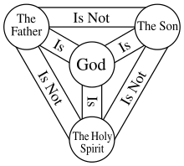
The "Shield of the Trinity" or Scutum Fidei diagram of traditional Western Christian symbolism

Let’s look at this symbol. What’s wrong with it?
“The Father is not the Son.” This is true! A father and a son are two separate beings, the son proceeding from the loins of his father, each with his authority-position. Looking at the Roman Catholic diagram above, the “Holy Spirit” is not the Son. That’s also true – but the “true” stops there.
The Father is the Spirit; the Spirit is the Father. If you go from Genesis to Revelation you will find there is a Father and a Son, two separate Beings of one substance – Deity. No, the Spirit is not the Son.
Again, the Son is not “God,” as in the Supreme Being, Elyon. It’s a matter of position. Yahuweh is from eternity past … He had no beginning and no end. Yahushua, being the Son, had a beginning, but will have no end. The Son is, however, Deity, for He was not created, but came forth out of His Father’s innermost being. The relation of Father and Son is a matter of rank only. My son is human because his father and I are human. Yahuweh didn’t beget a foreign child, neither did He create a Son. Yahushua was begotten as full Deity. In laying down His will to His Father, “in the fullness of time,” He took flesh. It is so simple if you see the Creator as all-powerful.
There is so much foolishness in mental wrangling that brings confusion. Our Father calls us “children.” He speaks to us simply as “children.” His ways are simple. Messiah calls us “sheep.” Sheep are stupid, smelly, and goofy. They’re cute, but they even look goofy. That’s mankind! But, He sees the potential of individuals, and He works with us to mature us. I’ll have to give credit to the sheep, however. When did you ever see a prideful, haughty, arrogant, self-righteous sheep? So, as an example, quoting theological terms from the article above, which defines God as three consubstantial persons, expressions, or hypostases is not something children and sheep would understand. Yahuweh’s doctrines are very, very simple! Look at the Ten Commandments! Even a sheep knows: “Stick close to your own shepherd.” Messiah said: “My sheep know My voice and they follow Me.”

Satan’s counterfeit came into the earth before the genuine? It sounds backwards doesn’t it? This is why so many who have no relationship with Yahuweh are denying the Son, saying that the New Testament is just a reproduction of paganism. They see that from before and after the Flood, gods had savior-sons, and that so much of what the New Testament speaks of was said about the pagan gods of old – Nephilim. But, these so-called intellectuals, given over the worship of man’s thinking, are messed up. There was life before Nimrod. Satan has been around a long time. From this last re-creation of the earth, and the separate creation of Adam and Eve, Satan has been at work trying to stop the plans of Yahuweh to save Himself a family. Satan, as the covering cherub (Ezekiel 28) over the throne of Yahuweh, before he got jealous and prideful and wanted to take Yahuweh’s throne for himself, knew many of the plans of Yahuweh for His family, including the Plan to cover the sin of Adam and Eve. He knew the Son. He knew that the Son was brought forth to redeem those that would fall away from His Father. He just didn’t know details. Yahuweh reserved many of His secrets from him. Satan knew many of the technologies of creation. Later he and his fallen ones gave this knowledge to man to corrupt the earth and the DNA of human beings. Because Satan knew beforehand some of the Plan for Redemption, and upon hearing Genesis 3:15, he went to work counterfeiting this plan by creating religions, starting shortly after the Flood. His plans have been very successful, but so have Yahuweh’s plans. Yahuweh already has Satan in “check mate!”
Thus, as part of the plan to thwart Yahuweh’s plans for redemption, we find that to extend themselves into the earth, fallen angels, Enoch says 200, came down on Mount Hermon (north Israel) and mated with human women producing Nephilim – spiritual beings with human flesh. These Nephilim, called “men of renown” in Genesis 6:2, 4, went on after the Flood to produce giants – Rephaim (i.e. the Anakim of Numbers 13:33). This is where we get the legends of the Egyptian, Babylonian, Greek, and Roman gods. They were, at one time, real beings, and some of them hybrids of other types. Moses killed lots of them, like Og and Sihon, and King David killed 11’ Goliath. Skeletal evidence is found of these hybrids in many places on earth. L.A. Marzulli in On the Trail of the Nephilim Parts I and II, show some of their huge elongated skulls of these beings from Peru– certainly not fully human. They’ve been discovered all over America, going back to the time when they dominated Bashan – the Golan Heights in north Israel. Most scholars, even secular ones like Fritz Zimmerman, an evolutionist, do not question these strange hybrid beings. Like Marzulli, Zimmerman believes the giants of America were from the Amorites, who fled the slaughter of the giants by Moses and his associates.
So, for Yahuweh, Creator of the universe, ultimate and most exalted Elyon, Shaddai, to place the seed of His Son into the womb of a virgin teenage girl in Israel to bring forth the mixture of Deity and humanity, for the purpose of saving a remnant of humanity, is not strange at all. It’s simple. While mockers and scoffers make fun of the “virgin birth,” these idiots strongly believe in the modern DNA tampering with the human genome.
This creation of hybrids, man-style, is going on in laboratories all over the world right now, with America in the lead. Hybrids of all types – human with animals, human with birds, fish, reptiles, and even plants – are abounding. Movies are showing these things – like “Splice.” But, high-brow theologians get all high and mighty that the Creator could not possibly have blended Deity with a pure innocent virgin girl’s flesh of the lineage of King David to bring forth His final Lamb for the salvation of the world. Oh the stupidity of religious theologians?

It is clearly stated in II Corinthians 3:17-18: II: “Now Yahuweh is the Spirit, and where the Spirit of Yahuweh is, there is freedom. And we all, with unveiled face, see as in a mirror the esteem of Yahuweh, and are being transformed into the same likeness from esteem to esteem, as from Yahuweh the Spirit.”
John 4:23-24: “The hour is coming, and now is, when the true worshippers shall worship the Father in spirit and in truth, for the Father seeks such to worship Him. Elohim is Spirit, and those that worship Him must worship Him in spirit and in truth.”
“Elohim” is the plural of Eloah, or Elah! (used in Daniel 2)
“In the beginning, Elohim created the heavens and the earth.” (Genesis 1:1) There were two present at creation – both Deity. Yahuweh orchestrated the re-creation. Yahushua spoke the words of creation. The Spirit, Yahuweh, went forth to perform the Word of His Son and caused creation to spring forth into reality. They still do that procedure with us.
But, also know that any father has a superior position of authority over his son, yet that in no wise puts the son on a lower level of being. Elohim our Father is the Supreme One – “God,” Shaddai, Elyon. He is supreme Deity. That means two things: 1) His Son is fully Deity, and 2) His son is not Elyon – the Most High - He is a Son – begotten, so that His nature is that of His Father. He is “echad” with His Father, but He is not His Father. He was begotten before the foundation of the world, whenever that originally took place. Thus, opposed to Catholic doctrine, the Son is not co-eternal – He did not exist with the Father from “the beginning.” He came into being sometimes “before the foundation of the world.” That means from the beginning of the created universe! Of course, the mind-blower is that Yahuweh is eternal—He had no beginning and will have no end. We finite humans can’t wrap our minds around that. For us, everything has a beginning.
So, somewhere before He originally created the universe (Genesis 1:1), Yahuweh brought forth Yahushua. “Yahuweh” means “I AM the ever-existing One who breaths.” “Yahushua” means “Yahuweh is salvation.”
It is clear from Scripture that Yahuweh let His Son have the privilege of speaking the words that caused the creation of the universe! Yahuweh is incredibly defensive of Yahushua, just as any good father is very defensive of the son that he is proud of. Yahuweh is very happy when we praise His Son! Aren’t you happy when others praise your child? Let’s get back to being children and sheep – simple.
Matthew 3:17: “This is My Beloved Son, in whom I am well pleased.”
Matthew 17:5: “This is My Beloved Son, in whom I delight – hear Him!”
Daniel 7:13-14 parallels Psalm 2:7-12. Yahuweh gives Yahushua His inheritance, and warns everyone, as in Deuteronomy 18:15-19, to honor and obey Him. A father with a good son is very proud of his son, and is highly indignant, even wrathful, if anyone tears down his son in any way! It is the same with Yahuweh and Yahushua.
Psalm 2:7: “Yahuweh said to Me, `You are My Son. Today I have begotten you. Ask of Me, and I will make the nations your inheritance.’ ”
The Hebrew word “begotten” means to bring forth, in the sense of having a baby, like the English word “begat.” From the inner being of Yahuweh, came forth Yahushua who took form as a man. He is called Yahuweh’s “only begotten Son.” All other “sons of Yahuweh” – His created children from Abraham, Yitzak, and Ya’cob, are adopted children. We are adopted. We were created. Let us realize that He is the Creator, we are the created, and act accordingly!
I John 2:22-23: “Who is the liar, except the one denying that Yahushua is the Messiah? This is the anti-messiah – the one denying the Father and the Son. No one denying the Son has the Father. The one confessing the Son has the Father as well. And as for you, let that stay in you, which you have heard from the beginning. If what you have heard from the beginning stays in you, you shall stay in the Son, and in the Father.”
In today’s world, there are few who understand the relationship between the Most High (Elyon) and His Son. To deny that the Father and the Son are two separate beings, “echad” in all ways, or to deny the Son’s Deity, or even to deny His existence at all, ends a person’s eternal life--for no liar enters the Kingdom. This is the spirit of anti-messiah. Yet, many of His people are denying the Son right and left to join up with religious intellectuals.
There is no salvation without the blood of the Lamb! (Leviticus 17:11, 14; Hebrews 9:22) Who gave Yahushua His blood? Whose blood was spilt for our sin? His blood, as with human children, came from His Father!
According to the whole Word and the nature of Yahuweh, I declare: I am not a Monotheist. I am not a Trinitarian. I belong to no religion. There is a Father and there is a Son, “echad” in all ways.

Proverbs 30:4: “Who has gone up into heaven and come down? Who has gathered the wind in His fists? Who has bound the waters in a garment? Who has established all the ends of the earth? WHAT IS HIS NAME, AND WHAT IS HIS SON’S NAME, if you know it?”

“In the beginning Elohim created the heavens and the earth.” (Genesis 1:1)
From Colossians 1:12-17: “…giving thanks to the Father who has made us fit to share in the inheritance of the set-apart ones in light, who has delivered us from the authority of darkness, and transferred us into the Kingdom of His dear Son, in whom we have redemption through His blood and forgiveness of sin, who is the likeness of the invisible Elohim, the first-born of all creation. Because in Him were created all that are in the heavens and that are on earth, visible and invisible, …all have been created through Him and for Him. And He is before all--in Him all things hold together.”
Hebrews 1:1-3: “Elohim, having of old spoken in many portions and in many ways to the fathers by the prophets has in these last days spoken to us by His Son, whom He has appointed heir of all things, through whom also He made the worlds, who being the brightness of His esteem and the exact representation of His substance, and sustaining all by the Word of His power, having made a cleansing of our sin through Himself, sat down at the right hand of the Greatness on high.”
Here I will pass on to you revelation knowledge from the Spirit that came from midrash with my son, Derek, yesterday. Over and over in this study, I say that the Father and the Son are “echad,” a Hebrew word meaning two in unity as one--a word that denotes family unity with the head of the house.
The will of Father and Son are perfectly “echad.” Think about it: If Yahushua’s will deviated from that of His Father for one nano-second, in the tiniest matter, the entire universe would collapse, because there would be a breach between them, and Messiah would be stripped of His power to hold everything together. Several times between John 7 and John 12, Messiah is quoted as saying that He does nothing, and says nothing, unless it comes from the Spirit, His Father. The Spirit of His Father came upon Him in great power at His mikvah in Jordan. In John 17, Yahushua reveals His oneness with His Father to His chosen inner circle of disciples. He tells them that He wants us to be “echad” as He and His Father are “echad.”
John 17:20-22, the High Priestly prayer of Yahuweh for you and me: “And I do not pray for these alone, but also for those believing in Me through their word, so they all might be one, as You, Father, are in Me, and I in You, so that they might be one in Us, so that the world might believe that You have sent Me. And the esteem that You gave Me, I have given to them, so they might be one, as We are One.”

John 12:48-50: “He who rejects Me and does not receive My words has one who judges him: The Word that I have spoken will judge him in the last days, because I spoke not from Myself but the Father who sent me has given Me command of what I should say and what I should speak. And I know that His command is everlasting life. Therefore, whatever I speak, as the Father has said to Me, I speak.”

Think about that. We are to pattern our life after that of our Master. We must allow the Spirit to transform our old carnal sin nature into the nature of Messiah, so that we think like He does, and act like He does. But, of course, we must seriously and methodically cooperate with the Spirit’s disciplines! No laziness allowed! The requirement of those born again is that we are like Messiah in this earth, giving His Word, and helping others to find Him. Can we afford to speak anything that is not first filtered through the mind of Yahuweh? If we speak on our own authority, what judgment awaits us?
The roots of religion are from the original worship of the Nephilim – the “men of renown,” the gods of old that were part demon and part human, or part human and part animal, bird, fish, or reptile. Religion was interpreted by priests, and so all religions have their roots in the Satanic kingdom! Yahuweh and His Son Yahushua Yahuweh have nothing ZERO to do with religion. He calls us out of all religions of man, to learn from Him.
If you’re stuck in a religion, get out! But, also REPENT, and seek to learn from Him! If you’ve been involved with any falsehood, REPENT, and turn from it, closing the portals of the enemy to it, so that you can go forward in the Truth! Repentance closes the portal of the past and sets you free!
In 1999, Abba took me to Jordan for 8 years to get all religion of man out of me. I was an ordained minister. I was a pastor, evangelist, missionary, apostle, and a teacher of the Word in many countries. I had my own non-profit corporation. He took all falsehood out of me as He taught me His Word by Himself. I am what He called me to be, but I dissolved all association with man-made groups, including my own corporation. The Word indeed will set you free! If you are not Spirit-taught, you’re not taught correctly … you have falsehood still clinging to your brain.
Psalm 2:11-12: “Serve Yahuweh with fear, and rejoice with trembling. Kiss the Son lest you perish in the way, for soon his wrath is to be kindled. Blessed are all those taking refuge in Him.”
For 1,000 years, a millennium, in the Kingdom of Messiah on this earth, Yahushua will reign with a rod of iron, sitting on His own throne, ruling over the earth as King and High Priest. His Father is backing Him 100%. (Zechariah 6:12-15; Revelation 19)
Yahuweh, the Father (Abba) is: Omniscient, omnipresent, and omnipotent. He is all knowing. He can be everywhere at once. He is the All-mighty – Shaddai. Yahuweh did not withheld knowledge from His Son, so Messiah is all knowing. But when He was on the earth, His knowing was limited of the future because He had to remain focused on the reason why He was sent to earth. So, He said in Matthew 24:35-36:”Heaven and earth shall pass away, but My words shall by no means pass away! But, concerning the day and hour (of His return) no man knows, not even the angels of heaven, but My Father only.”
Of course now He knows the exact timing of His return. Now, the angels loyal to Yahuweh and Yahushua know the exact timing, too. But, also, now Satan knows, those searching the Scriptures know, His watchmen know, the prophets know, but the world’s people, and those whose heads are stuck in traditional religion, know little to nothing. All they can do is to speculate.
Messiah is forever in a body – a spiritual body - like we’ll have at the resurrection, but still--a body. (Philippians 2:20-21; I John 3:1-3) He sits on a throne by His Father, waiting for His return-time.
He cannot be omnipresent. He is “in us” only through the nature of His Father’s Spirit. Messiah has His own spirit, like we do. The Father’s Spirit was with Him and in Him, just like with us who are Spirit-filled, when He was on earth, but the Spirit is not Messiah, Messiah is not the Spirit, Yahuweh is not Messiah, Messiah is not Yahuweh-- TWO BEINGS – A FATHER AND A SON! Child-like simplicity for humble people who know Them!
We know Messiah appeared many times on earth in His pre-incarnate form, and was worshipped as Yahuweh. And, it is exciting to see in so many passages of the Tenach where the Son and the Father are interchangeable. The only way you can tell if the passage is talking about Yahuweh or Yahushua is to note the time-period of the context, and by what He is doing. One illustration: In Zechariah 14:1-5, it says that Yahuweh comes with all the set-apart ones. He puts His foot on the Mount of Olives, which splits in two, and He enters the Temple Mount with all the saved of all generations, and sets up His Kingdom. That’s Messiah, who comes “in the Name of Yahuweh.” In Zechariah 6:12-15 He, the Branch, sits on His throne as both King and Priest. Messiah is known as the Branch. He will order the Ezekiel 40-46 Temple to be built after His return. NO temple has to be built for the Jews on the Temple Mount before Messiah returns. Foolish Christian teachers use the English “temple,” in II Thessalonians 2:4 to contradict the Tenach. The Greek word for “temple,” is more like an enclosed gazebo-- a little room where a deity sits, as in pagan temples. Certainly NOT the fully operational Temple of Ezekiel 40-46!
We know that Yahuweh dwells between the cherubim on the Ark in heaven – in His City – the New Jerusalem. (Psalm 99:1) We know that after the 1000-year reign of Messiah, ending with death being put under His feet forever, that Yahuweh brings His City down to hover over East Jerusalem. Then He takes the rule, and Messiah steps back. So, who has a foot to step down on the Mount of Olives? Who is the “right arm,” and “right hand” of Yahuweh who gains Him the victory?
“Blessed is He who comes in the Name of Yahuweh.” Only a son can officially come in the name of his father, at least by ancient Eastern Hebrew culture.

Where did Constantine get the trinity doctrine to incorporate into his church theology? He was a pagan sun-god worshipper to his death. The doctrine originated with Nimrod as the father sun-god, and his son, sun-god, Tammuz, and his mother/wife Semaramis not long after the Flood in Noah’s day. Like the attempted tower of Babel, it was built on the hate of Yahuweh and His Torah. The sun god simply became “God,” Tammuz became Iesous, or Jesus of the Greeks, and the dove image of a Holy Spirit came straight from the rays of dead Nimrod who rose to become the sun god, which impregnated Semaramis with Tammuz. Thus the white dove became inseparable from Semaramis. Such is Lucifer’s religion!
Nimrod hated Yahuweh, as did his father Cush, and the original father, Ham, son of Noah. Nimrod worshipped the god Marduk--Satan disguised. He tried to build a tower, with a star gate at the top, so that he could go into Yahuweh’s dimension and kill Him. (Genesis 10:6-12 and 11:1-9) He had the spirit of Satan/Lucifer.
You saw in some of those “lovely” paintings above that at the baptism of “Jesus,” a white dove came flying over His head. Did that really happen? Of course not! The pagan dove symbol represents a “Holy Spirit,” as the rays of the dead sun god, Nimrod, who impregnated Semaramis (his mother and wife) with her baby sun god – the son of god. The mother-child cult with its dove continued from the time of Nimrod into other pagan religions. From Roman Catholic Church theologians, this false thinking twisted the simple words of Matthew 3:16-17, so that today, verse 16 is used to “prove” the trinity.
Matthew 3:16-17: “And having been immersed, Yahushua went up immediately from the water, and see, the heavens were opened, and He saw the Spirit of Elohim descending LIKE A DOVE and coming upon Him, and see, a voice out of heaven saying `This is My Son, the Beloved, in whom I delight.”
Whether Catholic theologians inserted the part about the dove to emphasize their pagan trinity theory is not known. But, for sure, the words “LIKE a dove” are quite different from “a dove.” But, there’s a 99.9% chance that no little white bird came on Him at His baptism (mikvah). Notice the words “He saw the Spirit of Elohim.” I would say, most likely, that Matthew, a Hebrew, a Jew, would not have put the word “dove” in his writings. Yes, a dove moves swiftly, so “like a dove” would mean that the Spirit of Yahuweh quickly came upon Him. Church leaders, even Protestant Sunday School teachers, are quick to point out that in this scene is the trinity – the son being immersed, the Father speaking, and the dove thing being the “Holy Spirit.” But, to use this verse to prove a trinity, well, it just doesn’t fly (pun intended).
Another example of the Church’s finagling is Matthew 28:19: “Therefore go and make disciples of all the nations, baptizing them in the name of the Father, and of the Son, and of the Holy Spirit.”
“The name of?”-- “What name?” Kepha (Peter) baptized in the Name of Yahushua. What name was the common denominator? – always Yahu (I am) – Yahuweh -- the family Name.
To insert some precious humor: I had just finished a whole day of teaching in a pastor’s conference in Kisumu, Kenya. It was about 9:00 PM. I was sitting outside some mud huts, with kerosene lanterns burning. Pastors gathered to ask more questions. The lady-pastor to my right said, “We read in the Bible that heaven is His throne, and earth is His footstool. We have concluded that He must have very long legs.” That was no joke, just an honest inquiry. The man to my right said: “Now tell us, Jesus said to baptize in the name of the Father, the Son, and the Holy Spirit, but Peter said to baptize in the name of Jesus. Who was right – Jesus or Peter?” Great question! In the Messianic Writings, the people were baptized in the Name of Yahushua, which contains the Name Yahuweh!
I John 5:7-8 KJV: “And there are three that bear record in heaven, the Father, the Word, and the Holy Ghost; and these three are one. And there are three that bear witness in earth, the Spirit, and the water, and the blood, and these three agree in one.”
The Scriptures: “There are three that bear witness, the Spirit, and the water, and the blood, and the three are in agreement.”
The Latin Vulgate: “There are three witnesses in heaven: The Father, the Word, and the Spirit, and these three are one: there are three witnesses on earth: the Spirit, the water, and the blood.”
These words are not in any of the original Greek manuscripts!
Though to the modern mind, this sounds like a convincing argument for a trinity, the Word, and the blood, representing the Son.

To document some of the theological statements above, starting here, I take some quotes from Vain Traditions, pages 82-91. The author is not known, but it was published through via the Halleluyah Scriptures. It is a compilation of information like Fossilized Customs by Lew White, both which contain some serious doctrinal error, but the historical facts are excellent.
Speaking of the three Scripture portions above that are questionable:
“It is well known from early on, that these insertions by the Roman Catholic Church are fallacious. Yet, they just kept coming from the Latin into the English in most translations. This contradicts the whole of Scripture.
The doctrine of the Trinity is against, an enemy to, the reality of the Persons of Elohim.
Regarding Matthew 28:19: The Jerusalem Bible questions whether the formula given here for immersion is inspired or liturgical (added later by the church). The Hebrew version of Matthew omits the verse entirely. In all instances baptism is done in the Name of Yahushua. (Acts 2:38, 8:16. 10:48, 19:5, 22:16; Romans 6:2; Galatians 3:27)
Eusebius of Caesarea, considered by some to be one of the greatest Greek teachers and historians of the early church (270-340 CE), in citing Matthew, Eusebius omitted the Trinitarian formula found in Matthew 28:19. Eusebius quotes Matthew 28:19 21 times, omitting everything between `nations’ and `teaching’ or in the form `making disciples of all nations in My Name.’ In other words, the idea of baptizing people in the Name of the Father, Son, and Holy Spirit is just not there, and was not there until later, when the church added it.
Again, The Encyclopedia of Religion and Ethics says that Justin Martyr was also ignorant of the present form of Matthew 28:19. He quoted Isaiah and the practices of the Apostles to justify the practice of baptism by immersion.
Regarding I John 5:7-8: `Most Biblical scholars will admit that I John 5:7-8 was a later addition to the New Testament. In other words, this passage is not found in the oldest New Covenant manuscripts.’
For over 1500 years the church has taught the doctrine of the trinity, despite the fact that nowhere in Scripture do we find the word `trinity,’ or even the concept of three almighty beings in one. Even theological scholars admit this.
From the Classic Bible Dictionary by J.P. Green: `This is not itself a Biblical term but was coined by Tertullian…’
From Cyclopedia of Biblical, Theological, and Ecclesiastical Literature: `Respecting the manner in which the Father, the Son, and the Holy Spirit make one God, the Scripture says nothing…’
The doctrine of the trinity is often defined in the following terms: `The holy Trinity is one supreme being existing in three persons, equal in rank and in eternity and having the same substance, all united in one Godhead.’
From the International Standard Bible Encyclopedia: `The term Trinity is not a Biblical term …as the doctrine of the Trinity is indiscoverable by reason, and is incapable of proof from reason.’
From the Encyclopedia Britannica on the Trinity: `The doctrine developed over many centuries and through many controversies. The Council of Nicaea in 325 CE stated the crucial formula for that doctrine …even though it said very little about the Holy Spirit. By the end of the 4th century, the doctrine of the trinity took substantial form, the form it has maintained every since.’
Both secular historians and Bible scholars readily admit that the doctrine of the Trinity was not official church teaching until the Council of Nicaea in 325 CE.
From the New Catholic Encyclopedia 1967: `The formulation “one God in three Persons” was not solidly established, certainly not fully assimilated into Christian life and its profession of faith, prior to the end of the 4th century…Among the Apostolic Fathers there has been nothing even remotely approaching such a mentality and prospective.’
There you have it! The early Apostolic Fathers had no concept of a triune relationship among the Father, the Son, and Spirit. They also freely admit that the doctrine was not established until well over 400 years after the resurrection of Yahushua…The trinity is just another example of Catholic syncretism. Yet another pagan belief absorbed into Christianity to make it appealing to a one world religion…
From The Two Babylons by Alexander Hyslop: `Will anyone after this say that the Roman Catholic Church must still be called Christian, because it holds the doctrine of the Trinity? So did the pagan Babylonians, so did the Egyptians, so do the Hindus at this hour, in the very sense in which Rome does.’
From the Encyclopedia of Religion and Ethics: `Although the notion of a divine triad, or trinity, is characteristic of the Christian religion, it is by no means peculiar to it. In the Indian religion we meet with the Trinitarian group of the Brahma, Shiva, and Vishnu; and in Egyptian religion with the Trinitarian group of Osiris, Isis, and Horus, constituting a divine family, like the Father, Mother and Son in modern Medieval Christianity.’
From The Story of Civilization by W. Durant, Vol. 3: “Christianity did not destroy paganism, it adopted it. The Greek language, having reigned for centuries over philosophy became the vehicle for Christian literature and ritual. The Greek mysteries passed down into the impressive mystery of the Mass. Other pagan cultures contributed to the syncretistic result.’
From The Church of the First Three Centuries by Alvan Lamson: “…we must look not to the Hebrew Scriptures, or to the teachings of Yahushua and His Apostles, but to Philo and the Alexandrine Platonists. In consistency of this view, we maintain that the doctrine of the Trinity was a gradual and relatively late formation; that it had its origin source entirely foreign from that of the Jewish and the Christian Scriptures--that it grew up and was engrafted into Christianity through the Platonizing fathers.’ ”

In the King James Bible, and used in other languages too, the “Spirit” is called “the Holy Ghost.” In German: “Heiligen Giest.” In some English translations, there are even a few places where the Spirit is called “it.” In Hebrew He is the “Ruach ha Kodesh,” the Set-Apart Spirit. Yahuweh said: “Be set-apart for I am set-apart.” (Leviticus 11:44-45; 19:2; 20:7-8, I Peter 1:16) Yahuweh is the Ruach ha Kodesh! He is Spirit; He is THE Spirit! You can’t separate Yahuweh from His set-apart Spirit.
In Romans 8:11 and Joel 2:28, Yahuweh refers to the Spirit as His Spirit. But, you find this all through the Word. Remember that a “holy spirit” was the one who impregnated Semaramis by the rays of the sun, so that she would bring forth Nimrod reincarnated as Tammuz. Thus, throughout pagan history, whoever the cultural Queen of Heaven was, there was a “holy spirit” in the pantheon. By separating a “Holy Ghost,” or “Holy Spirit,” from Yahuweh, the Spirit can be made to be anything or do anything that a theological wants to invent.
Now, we find that the false foundation of unity to draw Charismatic Protestants into the Vatican is to emphasize the “Charismatic Renewal” within the Roman Church in the 1960s. The pope’s representative, the late Tony Palmer, said that it doesn’t matter about doctrine--we are one in the “Spirit.” But, the theological Roman Catholic “spirit” is not Yahuweh! By separating a “Holy Spirit” from Yahuweh, it opened the door for all sorts of man-made ideas to enter into Christian theology.
In the Charismatic movement, a separate “Holy Spirit” has been used to explain all kinds of phenomenon. Some of it is genuinely from Yahuweh! In the Acts the Apostles, His ministers ministered in the power of Yahuweh’s Spirit. Throughout the Tenach, the Prophets were filled with His Spirit, i.e. Ezekiel 2:2. King David prayed (Psalm 51) “take not Your Set-Apart Spirit from me.” A fresh final outpouring of His Spirit is prophesied in Joel 2. But, we also see that it is His pattern to withdraw His Spirit before times of judgment. (Ezekiel 8 – 11:23) That’s what is happening now.
The Set-Apart Spirit is Yahuweh. Genesis 1:2 – “the Spirit of Elohim moved upon the face of the deep. Yahuweh is omnipresent, omniscient, and omnipresent because He is Spirit!
The Spirit descended on the day of Pentecost (Shavu’ot/Leviticus 23:9-22), the 50th day after First Fruits (Acts 2). It was the day the Torah was given on Sinai – the marriage covenant between Yahushua and His Bride, given by Yahuweh, the Spirit. It was Messiah who gracious gave the Spirit of His Father to all who asked for Him. (John 15:26; 16:7-15; Luke 3:16)
Baptists and other Fundamental Christians say that the miraculous work of the Holy Spirit ceased with the deaths of the Apostles, as if they’re saying it made it true. No Scripture says that! They say we don’t need the Spirit manifesting anymore like He did back then because now we have the Word. That’s silly! The only “Word” mentioned in the New Testament is referring to the Hebrew Scriptures--the Torah, the Prophets, and the Writings. The Apostles used the Hebrew Scriptures. “The Word became flesh and dwelt among us.” Messiah was the embodiment of what Word? -- The Torah, Prophets, and Writings – the Tenach – the Word of His Father. To reject the Torah of the Hebrew Scriptures is to reject Messiah. There is no way that anyone can legitimately separate Messiah from His Father’s Covenant/Torah!

Upon entering our body, it is the norm for the Spirit to give a person a prayer language of angels, or a language of a nation. Sha’ul is very clear in I Corinthians 14 to bring order to the use of this gift, and other gifts of the Spirit. In most Fundamental Christian churches, the leaders boldly say that the manifestations of His Spirit are of the devil. They accuse the devil of doing things that are done by Yahuweh, because of their unscriptural theology of intellectual men, faithless men. But, oh how dangerous this is, even in ignorance! To attribute the workings of the Spirit (Yahuweh) to the devil is called “blasphemy against the Spirit.” It is the Spirit of Yahuweh that is sent into those that receive the Messiah by faith. This blasphemy has no forgiveness available to it. To blaspheme the Spirit is to blaspheme Yahuweh Himself. (Matthew 12:31-33; Mark 3:22-30)
[Refer to: “The Manifestations of the Set-Apart Spirit” under the mikvah of the Spirit on my website, comeenterthemikvah.com]
Yes, I know that there are false tongues and false signs and wonders. The False Prophet will deceive the world by his false signs and wonders, so that the world will worship the “Beast.” (Revelation 13)
But, for the discerning, the false tongues sound like the devil – all those ssss hissing sounds, and the false signs and wonders take people away from Yahuweh, not to Him. The Apostles guarded the Torah and all spoke in tongues, and they all did amazing signs and wonders in the Name of Yahushua. Sha’ul said: “I speak in tongues more than you all.”
By knowing the Word, it is easy to discern deception. But, also, the Spirit of Yahuweh in us brings “the gift of the discernment of spirits,” and without His Presence within us, we can be deceived in many ways. No one will survive the days to come without having the in-dwelling of the Spirit!
False prophecies like those of Kim Clement, and that fortune-telling Elijah List group, are blamed on the “Holy Spirit.” The operation of the Hindu Kundalini spirit in meetings like the “Toronto Blessing,” and the Lakeland, Florida revival, led by the guy with the tattoos that was having an affair with one of his co-workers, were blamed on the Holy Spirit. I highly recommend the YouTube teachings, and the 2010 book by Andrew Strom Kundalini Warnings, about the Hindu Kundalini Spirits that have invaded the churches. In those spurious revivals, the “Holy Spirit” was given credit for making people bark like dogs, roll on the floor like drunks, babble in demonic tongues,, jerk and twitch, roar like lions, and generally make utter fools of themselves. Oftentimes, there were sexual innuendos that accompanied those signs, as in Kim Clement meetings. Black-lighting and other such night club décor is used in Kim’s meetings – and it was all attributed to the “Holy Spirit.” Kim Clement made the statement that he didn’t need to read his Bible--the Spirit told him what to believe. My friends, these “spirits” that make human beings into blithering idiots is NOT Yahuweh! They come from the pit of hell!
By knowing the Word and guarding the Torah of His Kingdom, in humility and contriteness, we will not be deceived by all the weirdness that is coming on the earth. The Spirit of Yahuweh does everything “decently and in order.”
So, you’ve got charismatic groups blaming filth on the Holy Spirit, others denying His right to manifest, others who make Him out to be an “it,” or a force that is impersonal, others who actually attribute sexual experiences to Him, others blaspheme Him, but the greatest hoax of all is that He is separated from the very Person that He is - Yahuweh.
There is NO “HOLY SPIRIT” who is a separate entity from Yahuweh!
In fact, the expression “Holy Spirit” is used a very few times in the New Testament. The word “holy” is the name of a pagan goddess, so let go of that word. In Hebrew, the Spirit is the Ruach ha Kodesh--the Set-Apart Spirit--the Set-Apart Spirit of Yahuweh! This is how the Apostles and all early disciples understood it!
Tragically, things got mixed up when men reduced Yahuweh to the general title “God,” or “Lord,” -- elusive, conceptual, philosophical, theological titles that make Yahuweh a thing, not a Person. Messiah is titled “Lord” also. The word “Lord” is in the Tenach alone is used 6,823 times. Each time it nullifies, brings to nothing, the Name Yahuweh. This breaks the third commandment – bringing His Name to nothingness. To reduce Messiah’s name to a pagan Greek name from the god Zeus (Iesous/Jesu/Jesus), and also call Him “Lord,” is an to strip Him of who He is. The word “Lord” comes from the name of the Canaanite god, “Ba’al.”
When I was 4 years old, Messiah came to me in a most miraculous way – it was a tangible visitation as I rode in the backseat of my parents car along Huntington Beach. It was life-changing. After watching Him wrap a clear opaque bubble around me, I heard His voice, that lovely baritone voice of a young man speaking to me, separating me unto Himself.
Father’s voice is booming – thundering – like on Sinai. I have only heard His audible voice twice – very impressive! Messiah’s lovely baritone voice, the voice of a young man, is so precious and sweet, gentle and kind--UNLESS He is angry, then He speaks as if through gritted teeth. He makes His point.
Remember at the base of Sinai. Yahuweh was doing His thunder routine, and the people were scared to death. They begged Moses not to let Yahuweh speak to them. They only wanted to hear from Moses. Yet, Moses went into the Presence of Yahuweh many times, and enjoyed His Presence. He became a friend of Yahuweh. So, we see 4,000 years later what religion does. People go to man, not to Yahuweh. Religion separates man from hearing his Creator, and brings man under the control of human teachers. Don’t let that happen to you! Yahuweh and Yahushua still speak to Their friends today!
II Timothy 3:16: “All Scripture is breathed by Elohim.”
II Peter 1:20-21: “…No prophecy of Scripture came to be by one’s own interpretation, for prophecy never came to be by the desire of man, but men of Elohim spoke, being moved by Set-Apart Spirit.”
All through the Word we read that Yahuweh moved on the writers of Scripture…not some separate being that was a third part of a trinity.
Only one trinity exists, and it has its roots in Nimrod, Semaramis, and Tammus. This trinity will also manifest, in Revelation 16:13, as the Dragon, the Beast, and the False Prophet.
It was Yahuweh who said in Isaiah 66:13 (KJV) “as one whom his mother comforts, I will comfort you.” Yahuweh, the Spirit, has the tenderness of a mother. This tenderness is also found in a gentle, caring, and kind father. The characteristics of the nature of a loving human father also contain elements of a mother--nurturing, compassion, gentleness, kindness, affection, responsibility, helpfulness, etc. The characteristics of a loving woman also contain elements of the strength that a man has to have in order to fulfill her role. If our nature is that of Yahuweh, then we also have characteristics that He put in both men and women.
Genesis 5:1-2: “This is the book of the genealogy of Adam. In the day that Elohim created man, He made him in the likeness of Elohim. Male and female He created them, and He blessed them, and called THEIR NAME `ADAM,’ in the day they were created.”
The word “woman” simply denotes a “wombed man” – the man with the womb. “Man” is generic for human beings – Homo sapiens. Males have their nature and their responsibilities as leaders, equipped for their roles in life. A woman has her own nature and responsibility that equips her for her role in life. But, they both have general characteristics of their Creator which cause them to be “echad,” united as one in Him. It was sin that separated the perfect unity of Adam and Hawaah (Eve). “Sin is the transgression of the Torah.” (I John 3:4b) “Transgression” means to rebel, revolt, or apostatize. Yahuweh is definitely a Father. He never calls Himself a mother. He says in Jeremiah 31:9: “…I will be a Father to Israel, and Ephraim (he is My firstborn).”
In primary Christian theology, though not distinctly taught this way in most churches, the spirit and the thinking comes through that the God of the OLD Testament was mean, harsh, unloving, judgmental, critical, stern, unfeeling, and thus gave His people a hateful Law to put them in bondage--a law that no one could keep. They teach that Jesus came to do away with that horrible LAW OF THE JEWS that Moses wrote, and to give us freedom from having to obey such oppressive bondage. In Christian theology, the “Holy Spirit” sides with nice Jesus, but sometimes He does weird things as the “Holy Ghost” in Pentecostal meetings. As a previously ordained charismatic minister, I’ve been to those kinds of lively meetings, too. Since Yahuweh deals with individuals, some of that liveliness is really His Spirit, but, unfortunately, most of it is fleshly fervor. Thought not in most Christian’s conscious mind, the wrong attitude towards Yahuweh comes out at times, often when Torah is mentioned. But, in their actions and reasoning, Yahuweh is slotted as the “it” up in heaven, referred to as “God” – a God they don’t know, and most don’t want to know.
The Messianic Movement has opened up a more realistic view of the “God” of the Tenach. For this I am grateful. But, but at the same time many devalue Yahushua Messiah as not worthy of their submitting their lives to follow Him, and the “Brit Chadasha” (New Testament) as not worthy of their time to read it. But, then, by following the teachings of intellectual men, the Messianic Movement as a whole has become just another religion. However, by His mercy a small remnant has a relationship with Yahuweh and Yahushua! They are taught Their Word by Yahuweh’s Spirit, and align with Them as “echad.” The answer to Yahushua’s prayer (John 17) is taking place now with a small remnant. Remember the final end-time remnant not only believes in Messiah for their salvation, but they guard the Torah!
I know it must be strange to some of you to think of worshipped two--not one or three. But, that’s Yahuweh’s nature. Man gives two extremes, usually both wrong. But, Yahuweh is in the middle with His absolute Truth.
We’re all on a journey of learning and understanding, and if we love Truth, we are quick to change to adapt our thinking to Truth. On this journey, truth-lovers will have many shocks, that what they have believed about God, about Jesus, about the Holy Spirit, is mostly all false and unscriptural.
As a child growing up in the Baptist church, I was taught in Sunday School that God is like an egg--one egg with three parts: the yoke, the white and the shell. The Catholic Encyclopedia describes the trinity like this: “There is a sun--the Father, and its rays--the Son,--and its brightness the Holy Spirit.” Were you taught about the trinity using those illustrations?
Roman Catholic Church doctrine on the Trinity says that the Father poured Himself out and became the Son. This is “denying the Father and the Son” as two individual Persons.
Well, figure, if you only have one God with three personalities, then he must have poured himself into Jesus like pouring milk into a sark/sack. But, how did He do that when He was sitting on His throne between the cherubim? Oh yes – He is omnipresent, omniscient, and omnipotent. He just poured a little of Himself into Jesus – right? NO! How messed up can man get? It gets worse … In creating his doctrine for his new religion, which he was using to unite his fragmented empire, please all the pagans, and eliminate the true followers of the Hebrew Messiah at the same time, Constantine exalted the Greek Iesous as supreme God, making Iesous the main God to believe in. What he did was take all the gods worshipped in the Pantheon in Rome and consolidated them down to one God – Iesous/Yesu/ Jesus. In doing this, he relegated Yahuweh to the distant past. So where did Yahuweh go? – Under the bus of course.
Some Pentecostal groups have the “Jesus only” doctrine, saying that the only God in the Bible is Jesus. Oh what a mess comes from people’s human reasoning! Yahuweh is supreme Deity. His Son, also Deity, is a Son, with His own throne, authority, power, and directives. They are “echad.”
There is no foundation in Scripture that the Son is the Father. But, in stating so, Constantine rejected Greek Gnostic Christianity that said that the Son was only a created being. Both are wrong! Do you see how important it is for you to be Spirit-taught?
Elohim is “echad,” two in unity as One. The Hebrew singular for the Father is “Eloah,” “Elah,” or “El.” The plural is “Elohim,” -- the “im” makes it a plural.
Genesis 2:24: “For this cause a man shall leave his father and mother, and cleave to his wife, and they shall become one flesh.” (“one flesh” – echad!)
“Echad”: Two in unity as one … IT’S A FAMILY WORD!
From Rule by Secrecy by Jim Marrs, c. 2000, pages 327-328, 354: “To counter Arianism, (Arianism was named after the Alexandrian priest Arius, and taught that God created everything, including Jesus, and therefore Jesus was not himself God, but rather a heavenly teacher, a messiah) the Roman Emperor Constantine had convened the Council of Nicaea in CE 325. The council, under firm control of the Roman Church, declared that God was a Trinity--Father, Son and Spirit…Arius and his followers were banished.”
Deuteronomy 6:4: “Hear oh Israel: Yahuweh, our Elohim, Yahuweh is one!” The word “one” is “echad” in Hebrew – a family word, denoting two in unity as one.
Messiah said: “I and the Father are One.” He spoke Hebrew. That word for “one” is “echad.”
John 6:44-45: “No one is able to come to Me unless the Father who sent Me draws Him. And I shall raise him up in the last day…” The very word Machiach, or Messiah, means a “sent one,” an anointed sent one. If there is only one “God” who poured himself into Jesus, how can Jesus be sent? It takes a sender to send someone. Our Abba (Father) dwells between the cherubim in heaven on the Ark of the Covenant, His throne. (Psalm 99:1) He is Spirit. Out of His loins came One in His likeness in every way who could take form and later unite with a human body.
Yahushua Yahuweh, the Son, walked with Adam in the cool of the day in the Garden. Yahushua Yahuweh, the Son, was the one in Genesis 18 who appeared to Abraham. Through this visitation, He is called “Yahuweh.” Abraham spoke with Melch-zadok in Genesis 14:17-24, the King of righteousness. He may have been Yahushua, also, as Hebrews 7 indicates. Yahushua wrestled with Ya’cob (Genesis 32:24-30). He was with Daniel’s three friends in Daniel 3. He appeared before “the Ancient of Days,” the Father, in Daniel 7, and received His inheritance and an everlasting reign. He received an inheritance from His Father--Psalm 2.
He prayed to His Father in John 17 that we might be in unity as He is in unity with His Father – echad – as one in nature, in thinking, in ways of acting, in love, and in fellowship.
Philippians 2:5-11: Yahushua did not cling to His right as the Son of Elohim, but submitted Himself to His Father’s will and took human flesh to dwell among us. Yahushua was “slain before the foundation of the world,” because of the plan of His Father for the redemption of a remnant of His people. (Revelation 13:8)
While on earth, the Son was in constant communication with His Father. He spent whole nights in prayer to His Father, i.e. Mark 1:35, 6:46. If He was Yahuweh in a sack, who was He praying to? If He was simply Yahuweh acting as a Son, then who was He praying to?
In John 11:41, Yahushua prayed to His Father to raise Lazarus from the dead. In John 6:37-40, John 5:7-30, and John 14:21, 23-24, He consistently separates Himself and His Father.
Excerpts from Hebrews 1:1-6: “Elohim, having of old spoken in many places and in many ways to the fathers by the Prophets, has in these last days spoken to us by the Son, whom He has appointed heir of all things, through whom also He made the world, who being in the brightness of the esteem and the exact representation of His substance, and sustaining all by the word of His power, having made a cleansing of our sins through Himself, sat down at the right hand of the Majesty on high…to the Son He says: `Your throne O Elohim is forever and ever – a scepter of righteousness is the scepter of Your Kingdom…” Here Yahuweh calls His Son “Elohim.” - Two ruling Deity, on two separate thrones. (The author of Hebrews, quoting from Psalm 45:6)
Psalm 110:1: David speaking: “Yahuweh said to my Yahuweh.” Most translations put it this way: “Yahuweh said to my Master.” But, would King David call anyone except Deity his Master? I’ve done a thorough study on this Psalm. It is a totally Messianic Psalm from start to finish. It is quoted in the Messianic Writings. David’s Master was Messiah Yahushua Yahuweh. David understood that from his own loins would come the flesh of Deity, who would rule over the earth, with him as His “Vice President.” David even said so himself. He even called Him “the branch.” Isaiah 53 calls Him the branch out of Jesse – the father of King David. David’s Master was the Son of Yahuweh! [Refer to: “The Return of King David”/November 7, 2014]
Oftentimes, Yahuweh manifested in the form of a cloud. The people followed the cloud – if it lifted they moved camp, if it stayed stationary, they stayed in camp. (Numbers 9:16-21) Yahuweh operating in His omnipresence … manifested as a cloud for people to see. Messiah took flesh so that He could dwell with us. He never was a cloud. The Two manifest in different ways.
Joel 2:32: “Whoever calls on the Name of Yahuweh shall be saved.”
Psalm 118: “Blessed is He who comes in the Name of Yahuweh.”
Who came, and will come again in the Name of Yahuweh?
There are TWO--a Father and His Son. The family Name unites them. The Son is given a Kingdom to rule for 1,000 years. After the 1,000 years Yahuweh comes to rule forever (I Corinthians 15:23-28; Revelation 20)
Messiah’s Kingdom is a buffer between man’s rule for 6,000 years, and Yahuweh’s eternal rule beginning in the 8th millennium. The 7th millennium belongs to the Son. As of 2000/2001, we are inside the 7th millennium. The Son is on the way.
Psalm 2:12: “Kiss the Son lest He be enraged, and you perish in the way. For soon His wrath is to be kindled. Blessed are all those taking refuge in Him.” …” The word is “son” is “bar” in Hebrew. Religious Jews try to twist that Scripture, and so do modern translations, but then all Messianic passages in the Tenach have been twisted or changed somehow by rabbis. But, we are blessed if we take refuge in the One coming with His Father’s wrath. The Son comes with His wrath – the Word is full of information on this, i.e. Isaiah 34; 63:1-6; Zechariah 14:1-5; Revelation 11:15-18, and chapters 19-20.
What is Yahuweh doing while the “Day of Yahuweh” is taking place, while the earth is being destroyed and almost all of its people with His wrath? He is in His throne room. He has sent out all the angels. He is there alone, grieving. So, while Yahushua, the Son, is bringing His wrath on the world, He is between the Cherubim in heaven. He is now withdrawing, as Messiah waits to return … Yahuweh’s Spirit is leaving all except a small remnant with whom He can trust and deal with to do His will without compromise.
In Revelation 4 and 5, there are two worshipped--a Father, and the Son as the Lamb of Elohim who took away our sin.
“Let Us make man in Our image” – Genesis 1:26.
Genesis 11, regarding Nimrod’s tower of Babel: “Let Us go down…”
Isaiah 6, Yahuweh says to the prophet, “Who will go for Us”…
Messiah alludes to the coming of Iesous, the Greek Gnostic and later Roman counterfeit, in John 5:43: “I have come in My Father’s Name (Yahu – shua) and you receive Me not. Another shall come in his own name – him you will receive.”
Sha’ul (Paul) tells us that “the mystery of iniquity” was already at work in the 1st century CE. This “mystery of iniquity” is the great whore of end-time Babylon in bed with Rome – the 8th Beast of Revelation 17. In our day, we are watching the two become “echad.” They have been “echad” for nearly 400 years, but not as clearly as we see it now – America and the Vatican. Follow the pope’s visit to America in September 2015 closely, and ask the Spirit to show you what’s going on—really.
The Apostles fought against the rise of what became Roman Christianity and what would become “rabbinic Judaism.” [Refer to: “Exposing the Roots of Rabbinic Judaism and Its Link to Rome”/March 2009]
The Greeks tried to kill the Apostle Sha’ul because he taught that the Messiah guarded Torah and taught us to guard the Covenant of His Father. They were not just Greeks, but many were Hellenized Jews who had adopted the Greek culture and their gods to escape death under Antiochus Ephiphanes in 167 BCE. Because the Greeks and the Romans despised the Torah, and outlawed it, in Messiah’s day and afterwards, these Hellenized renegade Jews tried to stop any teaching of the Torah.

This is just a brief expose of this topic. I exhort you to get out of all paganism, and into the Truth of the whole Word, as taught by the Spirit of Yahuweh. Don’t be caught up in pagan doctrines any longer. Start in Genesis 1 and read through Revelation 22. It is one complete picture. Learn to know the real Yahuweh, and the real “Word made flesh.” What Word? – His Father’s Torah! The Messianic Writings speak very much about “the Word.” Just know that the only Word they had as their foundation for Truth was the Hebrew Tenach (the Torah, Prophets, and Writings).
Did Sha’ul guard the Torah and teach it? Oh yes – i.e. Acts 21:18-24. True Torah guarding believers in Messiah were never called “Christians.” They were called “the followers of the Way,” or the followers of the “Nazarene.”
(Hebrews 4:12-13; I Timothy 4:13; II Timothy 3:15-17; I Peter 1:20-21) Notice that the Word, the Tenach, is called “Scripture.” There is no verse in the Bible that says that The Messianic Writings are “Scripture.” The Messianic Writings were meant to build upon the Scriptures, carrying forth the fulfillment of prophecy, and exhorting people to believe in, and obey, Yahushua. The foundation for all belief must be the Tenach, and “in the mouth of two or three witnesses, let every word be established.” The Messianic Writings cannot stand alone. The Tenach can stand alone! For example, the Prophet Isaiah goes from eternity past to eternity future, giving much about Yahushua’s first coming, His second coming, and His Kingdom. Read the Word for yourself. A helpful book that reviews 25 Christianese words that come from paganism, for your information, is C.J. Koster’s book Come Out of Her My People.
May you love truth with all your heart and pursue it!
Begun November 18, 2012; rough draft finished June 2014; edited for publishing February 12, 2015
With shalom and His love,
Yedidah

